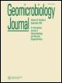**Geomicrobiology Journal**

**ISSN: (Print) (Online) Journal homepage:** [**https://www.tandfonline.com/loi/ugmb20**](https://www.tandfonline.com/loi/ugmb20)



**Isolation and Identification of Phosphate Solubilizing *Bacillus* spp. from *Tamarix ramosissima* Rhizosphere and Their Effect on Growth of *Phaseolus vulgaris* Under Salinity Stress**

**Ali Abdelmoteleb & D. Gonzalez-Mendoza**

**To cite this article:** Ali Abdelmoteleb & D. Gonzalez-Mendoza (2020): Isolation and Identificationof Phosphate Solubilizing *Bacillus* spp. from *Tamarix ramosissima* Rhizosphere and TheirEffect on Growth of *Phaseolus vulgaris* Under Salinity Stress, Geomicrobiology Journal, DOI:

[10.1080/01490451.2020.1795321](https://www.tandfonline.com/action/showCitFormats?doi=10.1080/01490451.2020.1795321)

**To link to this article:** <https://doi.org/10.1080/01490451.2020.1795321>



Published online: 25 Jul 2020.



[Submit your article to this journal](https://www.tandfonline.com/action/authorSubmission?journalCode=ugmb20&show=instructions) 



Article views: 7



[View related articles](https://www.tandfonline.com/doi/mlt/10.1080/01490451.2020.1795321) 



[View Crossmark data](http://crossmark.crossref.org/dialog/?doi=10.1080/01490451.2020.1795321&domain=pdf&date_stamp=2020-07-25)



Full Terms & Conditions of access and use can be found at

<https://www.tandfonline.com/action/journalInformation?journalCode=ugmb20>

GEOMICROBIOLOGY JOURNAL

<https://doi.org/10.1080/01490451.2020.1795321>



Isolation and Identification of Phosphate Solubilizing Bacillus spp. from Tamarix ramosissima Rhizosphere and Their Effect on Growth of Phaseolus vulgaris Under Salinity Stress

Ali Abdelmoteleba and D. Gonzalez-Mendozab

aBotany Department, Faculty of Agriculture, Menoufia University, Po, Shebin El-Kom, Egypt; bInstituto de Ciencias Agrıcolas de la Universidad Autonoma de Baja California (ICA-UABC), Ejido Nuevo Leon, Baja California, Mexico

ABSTRACT

The use of rhizobacteria associated with plant roots in extreme environments could be a promising strategy to overcome the limitations of crop production induced by soil salinity. In the present study, we isolated phosphate solubilizing bacteria from the rhizosphere of Tamarix ramosissima which is common native plants grown on a saline-alkaline site, to investigate the ability of these bacteria to alleviate salt stress in common bean (Phaseolus vulgaris cv. Karnac) plants. Among 5 isolates could solubilize phosphate, we selected the two most efficiency isolates No. 4 (AL-18) and No. 2 (AL-19). The partial sequence of 16S rDNA genes and phylogenetic tree indicated that AL-18 and AL-19 related to Bacillus megaterium and Bacillus cereus respectively. B. megaterium AL-18 and B. cereus AL-19 could survive and solubilize inorganic phosphate up to 14% NaCl. Maximum solubilization of tri-calcium phosphate (TCP) by both strains was observed at 6% NaCl and pH 7. The effect of selected strains on common bean growth under salt stress was conducted in pots experiments under green-house condition. Growth parameters including root length, plant height, root and shoot dry weight, phosphate content in plants and photosynthetic pigments were significantly increased by single and dual inoculation of the two selected strains under salt stress conditions. In conclusion, our results showed that inoculation of Phaseolus vulgaris with B. megaterium AL-18, B. cereus AL-19 isolated from the rhizosphere of Tamarix ramosissima, can alleviate the deleterious effects of salinity and improve plant growth, phosphate uptake and photosynthetic pigments under salt stress conditions, which were demonstrated in vivo. However, field experiments under natural conditions are needed to study the mechanisms by which the identified strains induce salinity tolerance in plants.

ARTICLE HISTORY

Received 1 June 2020

Accepted 9 July 2020

KEYWORDS

Biomineralization; salt stress; plants; Bacillus

Introduction

Salinity is one of the most factors that impede plant growth, development and crop production in several worldwide. Soil salinity inhibits plant growth through affecting several physio-logical and biochemical processes, like nutrients uptake, respir-ation, photosynthesis and carbohydrates translocation which reflecting on reduction of plant yield and causing great eco-nomic losses. (Khaitov et al. 2020). The rapid development of saline-alkali soil-based agriculture and intensive cultivating of salt-tolerant plants led to decline phosphorus availability in saline-alkali soil (Suleman et al. 2019; Zhu et al. 2011). In this context, soil microorganisms play a potential role in many of biological processes such as P-insoluble transformation to sol-uble form in soil which can uptake by plants (Suleman et al. 2019). The negative effects of soil salinity on plant growth could attribute to restriction of water absorption, osmotic stress and imbalance uptake of essential nutrients (Hahm et al. 2017). In recent years, several alternative have been used to alleviate the salinity effects on plants, including manage-ment of irrigation, proper agricultural practices, traditional

breeding for salt-resistant cultivars, phytoremediation, remove excess soluble salts by leaching it’s from upper to lower soil depths, cropping and leaching as well as genetic engineering (Albdaiwi et al. 2019; Ramadoss et al. 2013). The alternative strategy to alleviate salt stress is crop seeds and seedlings inoculation with plant growth promoting bacteria (PGPB). Several bacteria that have ability to grow in the absence of salt and in the presence of high salt concentrations (33%) are known as halotolerant (Ramadoss et al. 2013). The application of salt tolerant bacteria associated with roots of native plant in harsh environments could be play a vital role to mitigate the deleterious effects of salt stress and improve crop productivity (Zhou et al. 2017). The potential of plant growth-promoting rhizobacteria (PGPR) to alleviate the negative effect of salt stress on plants have been reported previously (Hahm et al. 2017; Zhou et al. 2017). PGPR could be promoting plant growth via multiple traits able to increase plant growth and crops productivity and useful in alleviating the negative effect of abiotic stresses directly and indirectly. There are hypothe-size say that, plant growth promoting bacteria isolated from naturally salt affected sites could be promising candidate to

CONTACT D. Gonzalez-Mendoza  danielg@uabc.edu.mx  Instituto de Ciencias Agrıcolas de la Universidad Autonoma de Baja California (ICA-UABC), Carretera a Delta s/n C.P. 21705, Ejido Nuevo Leon, Baja California, Mexico

2020 Informa UK Limited, trading as Taylor & Francis Group

2  A. ABDELMOTELEB AND D. G. MENDOZA

help ameliorate the effect of salinity stress on plants. It was found that, microorganisms surviving at harsh environments are suitable for application in several agricultural practices (Ramadoss et al. 2013). Tamarix ramosissima plant commonly known as salt cedar or tamarisk belongs to the family Tamaricaceae. The Tamarix species grow well on saline and alkaline soil. T. ramosissima widely distributed in western United States and Mexico especially in Sonora, Baja California and Chihuahua deserts (Sultanova et al. 2001; Villar et al. 2014). The present study aims to isolate phosphate solubilizing bacteria from the rhizosphere of a Tamarix ramosissima that growing in salinity site. Identify the most effective bacterial isolates based on 16S rDNA sequencing and evaluate their abilities to grow and solubilize inorganic phosphate under dif-ferent levels of salinity and pH. On the other hand, the com-mon bean, Phaseolus vulgaris L., is one of the most important grain legume crops present all over the word, and third in importance after soybean and peanut (Rady et al. 2018). It is the most important plant-based protein source for the people of eastern and southern Africa and fourth in Latin America (Morales-Santos et al. 2017). However, Phaseolus vulagaris is extremely sensitive to salinity (72 mM, pH 6), and suffers yield losses at soil salinity of less than 2 dS m 1 (Ayra et al. 2018). Therefore, the evaluation of inoculation of selected strains on growth parameters of Phaseolus vulgaris under salinity stress conditions was evaluated.

Materials and methods

Isolation and qualitative screening of phosphate solubilizing bacteria

For isolation of rhizobacteria with phosphate solubilizing activ-ity, approximately 500 g of representative soil samples were collected from rhizosphere of Tamarix ramosissima in Mexicali valley (32 240 3400N, 115 1101600O), Mexico, that grow in saline affected site at a depth of 15 cm from 5 different points within the area. The samples were air dried, mixed well and sieved through a 2-mm mesh. The sample was dispersed in sterile distilled water, vortex and serially diluted down to 10 7. 0.1 mL from each dilution of 10 5, 10 6 and 10 7 was spread on Pikovskaya (PVK) media agar plates supplemented with 0.1 g/L of Bromocresol Purple as a pH indicator dye, tri-calcium phosphate (TCP) as a sole source of phosphate. The colonies that acidified the medium (change in color from pur-ple to yellow) and produced clear zones around colonies were selective. The isolated individual colonies were re-spotted into new PVK plates for better analysis of clearing zone formation and calculation of solubilization index. All plates were incu-bated at 30 C for up to 3 days. The selection of most effective isolates for phosphate solubilization was done by observing the clear zone around the colonies and calculating of solubilization index (SI) of bacterial culture spots on PVK agar plate accord-ing to Batool and Iqbal (2019) from the following formula:

Solubilization Index ð SIÞ ¼ halo zone diameter þ colony diameter colony diameter

The most powerful phosphate solubilizing isolates were named as AL-18 & AL-19 and selected for further studies.

Molecular identification of strains AL-18 and AL-19

For extraction of bacterial genomic DNA, bacterial cells were collected from 1 ml of freshly grown culture on nutri-ent broth by centrifugation. DNA was extracted by the phe-nol/chloroform method according to Mendez-Trujillo et al. (2013). The amplification of 16S ribosomal DNA (rDNA) was carried out by polymerase chain reaction (PCR) with forward primer 27 F as 50-AGAGTTTGATCCTGGCTCAG-30 and reverse primer 1495 R as 50-CTACGGCTACCTT GTTACGA-30 (Zhang et al. 2013). PCR reaction was per-

|  |  |  |  |  |
| --- | --- | --- | --- | --- |
| formed by initial denaturation at 94 | | | C for 4 min, followed | |
| by 35 cycles of 94 | | C for 1 min, 59 | C for 1 min and 72 C | |
| for 2 min, | with a | final extension at | 72 | C for 8 min. The |
| 30 ll PCR | mixtures contained 1.2 ll of | | | each primer, 1 mL |

10 mM dNTP, 3 mL 10x PCR buffer, 2.5 mL 50 mM MgCl2, 0.3 mL (5 units/mL) of Taq polymerase (BIORAD, USA), and 2 mL template (20 ng of DNA). Amplification was performed in a DNA thermal cycler (BIORAD, USA). PCR product was resolved by electrophoresis in a 1% (w/v) agarose gel and visualized by Ethidium bromide staining under a UV transillumination imaging system. The PCR product was purified and sequenced by GENEWIZVR laboratory (South Plainfield, NJ 07080-USA) with forward primer 27f. The 16 s rDNA gene sequences were compared with those available in databases using the NCBI BLAST algorithm ([http://blast.](http://blast.ncbi.nlm.nih.gov/Blast.cgi) [ncbi.nlm.nih.gov/Blast.cgi](http://blast.ncbi.nlm.nih.gov/Blast.cgi)). The 16S rDNA gene sequence data was analyzed on the MEGA10.1.5 program and the phylogenetic tree was constructed using the neighbour-join-ing method.

Phosphate solubilization and pH changes in PVK liquid medium

The two selected strains AL-18 and AL-19 (1 mL of each isolate 107 cfu mL 1) were inoculated into 200 mL of Pikovskaya broth media supplemented with Ca3(PO4)2 and cultured at 30 C for 7 days with continuous agitation (125 rpm). For the determination of acidity and available phosphorus released from solubilization of TCP, 10 mL cul-ture was sampled aseptically every 24 hours, and centrifuged at 12,000 rpm for 10 min. The acidity was assayed simply by reading on a pH meter, and the phosphorus availability in the supernatant was quantified daily for 7 days using ‘QuantiChromTM Phosphate Assay Kit (DIPI-500)’ (Hildebrand et al. 2009).

Salt tolerance assay of strains AL-18 and AL-19

Bacillus megaterium AL-18 and B. cereus AL-19 were tested for salinity tolerance on nutrient broth media amended with NaCl at different concentrations (0, 2, 4, 6, 8, 10, 12, 14, and 16%), (Zhu et al. 2011). Overnight bacterial cultures of AL-18 and AL-19 were individually inoculated in triplicates of each concentration, and incubated with shaking at 130 rpm and 30 C for 48 hours. Bacterial growth was meas-ured Spectrophotometry at 600 nm, using un-inoculated media as blank.

Effect of salinity stress on phosphate solubilization

The evaluation of salt stress on phosphate solubilization rate was conducted by the inoculation of B. megaterium AL-18 and B. cereus AL-19 individually into flasks (125 mL) con-taining 50 mL Pikovskaya’s broth medium supplemented with different concentrations of NaCl 0, 2, 4, 6, 8, 10, 12, and 14%. All treatments in triplicates were incubated at 30 ± 2 C for 4 days on a rotary shaker at 125 rpm. After incubation, the liquid cultures were centrifuged at 12,000 rpm for 8 minutes to collect the supernatant. The concentration of soluble phosphorus in the supernatant was quantified via ‘QuantiChromTM Phosphate Assay Kit (DIPI-500)’ as reported above (Hildebrand et al. 2009).

Effect of different pH conditions on phosphate solubilization

To study the effect of varying pH media on soluble phosphate releasing in Pikovskaya’s broth containing TCP was deter-mined by adjusting the initial pH of the culture media to 5, 6, 7, 8, 9, and 10 pH using hydrochloric acid 2 N and sodium hydroxide 2 M, one mL overnight culture of each strain (AL-18 and AL-19) was inoculated in 250 ml Erlenmeyer flask con-taining 100 mL Pikovskaya’s broth at various pH. All treat-ments were carried out in triplicate and incubated at 30 C ± 2 on rotary shaker at 125 rpm. After for 4 days of incubation, all samples were centrifuged at 12,000 rpm for 8 minutes and the soluble phosphorus was measured in the supernatant.

Effect of strains on growth of Phaseolus vulgaris seedling under salinity stress

Effect of B. megaterium AL-18 and B. cereus AL-19 inocu-lants on phosphorus uptake and growth of Phaseolus vulga-ris (cv. Karnac) under salinity stress was carried out under greenhouse conditions in pot experiments. Pots of 25 cm diameter and 30 cm depth filled with non-sterile saline soil collected from affected site Dakahlia, Egypt, which has char-acteristics as follow: Clayey soil, pH 7.8, available-P (P2O5) 17 mg/kg, Available K 231 mg/kg, total nitrogen 24 mg/kg, E.C (7.68 ds.m 1), CaCO3 3.1%, organic matter 1.2%. The experimental design incorporated four treatments un-inocu-lated control, inoculated with B. megaterium AL-18, inocu-lated with B. cereus AL-19, inoculated with AL-18 þ AL-19. All pots were supplied with N and K fertilizer rates based on the nutrient requirements of P. vulgaris plants, and TCP (150 mg/kg soil) was used instead of P fertilizer. Plant seeds were surface-sterilized by immersing in 0.1% sodium hypo-chlorite for 8 min then 70% ethanol for 2 min and followed by washing three times with sterilized distilled water. Surface sterilized seeds were inoculated by soaking in separ-ate bacterial suspensions (107 CFU/ml) 45 min prior to culti-vate, dual inoculation was occurred by soaking in mixed two cultures. 6 seeds per pot were planted then thinned down to four plants per pot after one week. The pots were kept 25 days in greenhouse and after that the plants were harvested to assess the effect of inoculants on plant growth.

GEOMICROBIOLOGY JOURNAL  3

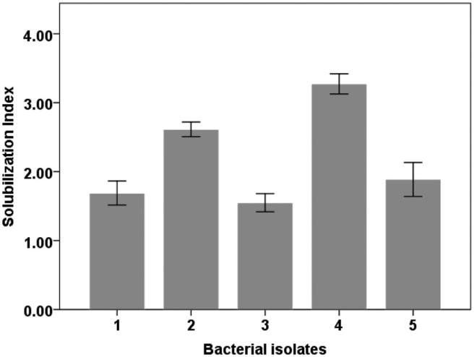

Figure 1. Phosphate solubilization index of different bacterial isolates from rhizosphere of T. ramosissima after 3 days of incubation in Pikovskaya medium.

Shoot and root length, dry matter and P content via Vanadate-Molybdate method in common bean plants were measured. Photosynthetic pigments including Chlorophyll a, b and carotenoids were determined by spectrophotometer methods (Lobato et al. 2010).

Statistical analysis

The experiments were analyzed by ANOVA and the means were compared with Tukey’s test at p < 0.05 for laboratory tests. Results are presented as means of three replicates ± - standard deviation. Pot experiments data were statistically processed at 5% significance level by Duncan test.

Results

Isolation and qualitative estimation of phosphate solubilizing bacteria

In this study, five bacterial isolates in total, which has been labeled from 1 to 5, were obtained from rhizosphere of T. ramosissima. All isolates were capable of solubilizing tri-cal-cium phosphate in PVK agar medium as shown by the appearance of clear zone around the colonies after three-day incubation. Solubilization index (SI) ranged from 1.55 to 3.27. The maximum SI was recorded by isolate No. 4 (Strain AL-

1. and Isolate No. 2 (Strain AL-19) with values of 3.27 and 2.61, respectively, which were significantly higher than those of the other isolates. While, the minimum SI was observed by isolate No. 3. The solubilization index of the five isolates is recorded and the results are illustrated in Figure 1. The most efficient isolates for phosphate solubilization are isolate No. 4 and isolate No. 2, respectively, which were chosen based on the solubilization index for further studies.

Molecular identification of strains AL-18 and AL-19 based on 16S rDNA sequences

The genetic analyses of the isolate No. 4 (AL-18) and isolate No. 2 (AL-19) showed high similarity to bacteria belonging

4  A. ABDELMOTELEB AND D. G. MENDOZA

to the genera Bacillus. The blast results of isolate AL-18 and AL-19 showed >94% similarities between available GenBank entries in which isolate AL-18 was identified as Bacillus megaterium strain AL-18 and AL-19 was identified as Bacillus cereus strain AL-19. The BLAST searches revealed that the 16S rRNA gene of isolate AL-18 shared 96.20% similarity to B. megaterium strain YLB-P3 (Genbank acces-sion number KF376340) and 96.09% similarity to B. megate-rium strain HTI 17 (Genbank accession number MK521065), while the 16S rRNA gene of isolate AL-19 shared 94.43% similarity to B. cereus strain CS3 (Genbank accession number MG601135) and 94.07% similarity to B. cereus strain CS9 (Genbank accession number KY307899). The sequences of these strains were submitted to the NCBI database and the accession numbers were (MN630227) and (MN882664) for B. megaterium AL-18 and B. cereus AL-19, respectively.

To disclose the taxonomic position and relationships, the phylogenetic tree based on the partial 16S rDNA gene of strains AL-18, AL-19 and some closely related sequences obtained from NCBI by using neighbor-joining method was constructed and shown in Figure 2. The evolutionary dis-tance dendrogram revealed that both strians AL-18 and AL-19 affiliated to the genera of Bacillus, a lineage of domain Bacteria. From the phylogenetic tree, strain AL-18 was closely related to Bacillus megaterium and the strain AL-19 was closely related to Bacillus cereus. The number beside the node is the statistical bootstrap value.

Phosphate solubilization of the strains AL-18 and AL-19 and pH changes

The phosphate solubilization activity by both strains AL-18 and AL-19 was estimated, change in pH was measured at different incubation times, and the results are given in Figure 3. Both selected strains presented good potential for solubilizing inorganic phosphate, indicated by a rapidly

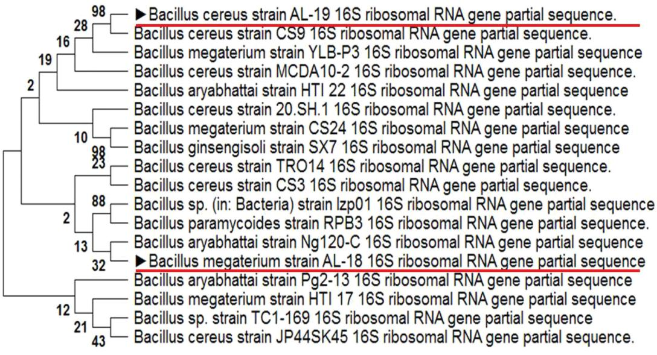

increase in the amount of soluble phosphate with incubation periods initiating from the first day and reaching at highest on 3rd and 4th day of incubation. Amount of soluble phos-phate released from TCP by bacterial strains was ranging from 68.3 ± 4 lg/mL to 283.5 ± 7 lg/mL. In case of strain AL-18, a significant increase in the amount of soluble phos-phate from the first day of incubation till reaching to high-est amount (283.5 ± 7 lg/ml) on 4th day was observed, followed by gradual and slow decline in the rest of incuba-tion period. While, in case of strain AL-19 the highest potential of phosphate solubilization with amount of soluble phosphate (140.2 ± 4.37 lg/mL) was recorded at 3rd day, and after that slowly decreased until 7th day of incubation. In this study, a significant decrease of pH values ranged from initial value 7.0 to lowest value 4.7 was observed for the both strains (AL-18 and AL-19). The pH reduction of the culture medium was accompanied with the increasing of sol-uble phosphate concentrations (Figure 2). The results showed that there is a direct inverse relationship between the pH value and soluble phosphate concentrations of media. Where, both tested strains AL-18 and AL-19 exhib-ited maximum drop in pH value 4.7 and 5.2 compared with initial value 7.0 at 4th and 3rd days, respectively.

Effect of NaCl on bacterial growth of AL-18 and AL-19

The results presented in Figure 4 revealed that bacterial growth significantly affected by salt different concentrations. A significant increase in the growth of both strains accom-panied with the increase of salt concentrations up to 6% NaCl was observed. After there, the increase of salt concen-tration from 8 to 14% caused of significant decrease (p < 0.01) in the growth of both strains. Generally, both strains able to grow under salinity stress up to 14% NaCl, while, bacterial growth of both strains was prevented at 16% NaCl, which indicated that both AL-18 and AL-19 are toler-ant to high salt concentrations up to 14% NaCl. The highest

Figure 2. Phylogenetic tree based on 16S rRNA gene sequences, showing the position of the bacterial strains AL-18 and AL-19 with respect to related species.

GEOMICROBIOLOGY JOURNAL  5

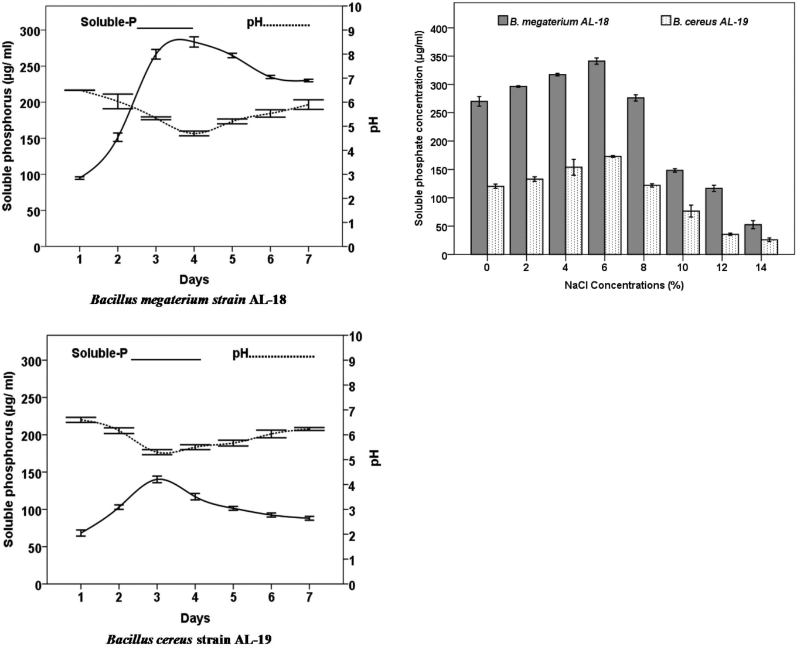

Figure 3. Quantitative estimation of phosphate solubilization and pH reduction by B. megaterium AL-18 and B. cereus AL-19.

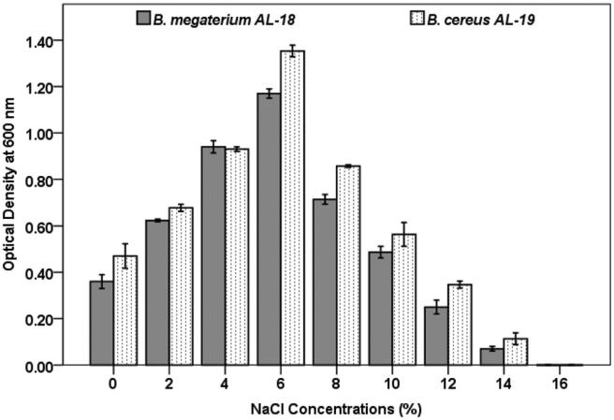

Figure 4. Effect of different concentrations of NaCl on bacterial growth of B.

megaterium AL-18 and B. cereus AL-19.

significant (p < 0.01) bacterial growth was recorded at 6% NaCl which were 1.17 ± 0.02 and 1.35 ± 0.025 OD at 600 nm for B. megaterium AL-18 and B. cereus AL-19, respectively. While the lowest significant (p < 0.01) growth was recorded

Figure 5. Effect of different concentrations of NaCl on phosphate solubilization by B. megaterium AL-18 and B. cereus AL-19.

at 14% NaCl which were 0.07 ± 0.01 and 0.11 ± 0.02 for B.

megaterium AL-18 and B. cereus AL-19, respectively.

Phosphate solubilization under salinity stress

The ability of strains AL-18 and AL-19 to release soluble phosphate from TCP in broth media amended with different concentrations of NaCl was conducted and the results are shown in Figure 5. It was found that solubilized phosphate amount significantly increase with salt concentrations increase up to 6% NaCl and decreased thereafter at rest of NaCl concentrations. Among the different salt concentra-tions, the highest significant (p < 0.01) amount of soluble phosphorus (341.16 ± 5.57 and 172.96 ± 1.59 lg/mL) was recorded at 6% NaCl for strains AL-18 and AL-19, respect-ively. While phosphate solubilization rate was decreased in cases of increase or decrease NaCl concentration than 6%. The lowest significant solubilization of phosphate

(52.5 ± 6.97 and 25.83 ± 3.26 lg/mL) was observed at 14% NaCl in both AL-18 and AL-19, respectively, comparing with other tested concentrations. Similarly, Pseudomonas aeruginosa isolated from paddy

Effect of pH on phosphate solubilization

The effect of initial pH of culture media on the release of soluble phosphate from TCP by both strains AL-18 and AL-19 has been showed in Figure 6. The results revealed that the pH has a significant effect on the rate of phosphate solu-bilization by both strains, which both able to release of sol-uble phosphorus from TCP in a wide range of pH from 5 to 9 pH. The highest significant concentration of soluble phos-phate (282.9 ± 3.5 and 128.36 ± 3.05 lg/mL) was observed at pH 7, followed by pH 6 and pH 8 for AL-18 and AL-19 respectively. While, the lowest significant soluble phosphate concentration was recorded at pH 5 and pH 9 for AL-18 and AL-19 respectively.

6  A. ABDELMOTELEB AND D. G. MENDOZA

Effect of selected strains on growth of common bean under salinity stress

The influence of halotolerant phosphate solubilizing B. megate-rium AL-18 and B. cereus AL-19 inoculation on growth of common bean was conducted under salinity stress. Growth parameters (Root length, plant height, root and shoot dry weight and phosphate content in the plant) were recorded after 25 days of cultivation (Table 1). The results showed that the growth parameters of common bean were improved by bacterial inoculation under salt stress. In the present study, the inoculated plants by B. megaterium AL-18, B. cereus AL-19 and both strains exhibited significantly (p < 0.01) increase in plant height, root length, root and shoot dry weight as com-pared with un-inoculated control. No significant (p 0.05) dif-ference in plant height, root length, root and shoot dry weight was observed among inoculation with AL-18 and AL-19. While co-inoculation with both strains showed the highest sig-nificant increase (p < 0.01) in growth parameters comparing to single inoculation and un-inoculated control. Phosphate con-tent in plants exhibited the same trend of growth parameters. Whereas, the highest significant (p < 0.01) content of phos-phate (0.60 ± 0.05%) was recorded in plants co-inoculated with both AL-18 and AL-19 strains followed by single inoculation by each strain in comparison to un-inoculated control.

Photosynthetic pigments

The effect of bacterial inoculation on photosynthetic pig-ments (chlorophyll a, b and carotenoids) of common bean plants under salt stress was presented in Figure 7. Overall,

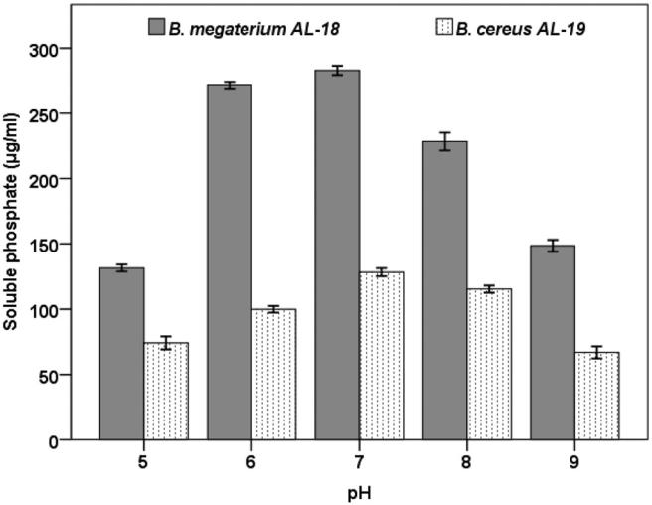

Figure 6. Effect of initial pH of culture media on phosphate solubilization by B.

megaterium AL-18 and B. cereus AL-19.

single inoculation or dual inoculation with both strains (AL-18 and AL-19) significantly increased the content of photo-synthetic pigments in common bean plants under salt stress condition. The highest significant (p < 0.05) increase in chlorophyll a, chlorophyll b and carotenoid contents was recorded by dual inoculation with AL-18 and AL-19 when compared to single inoculation and non-inoculated control. Also, single inoculation with each strain led to a significant (p < 0.05) increment in photosynthetic pigments when com-pared to non-inoculated control, but non-significant (p 0.05) difference between each other was observed.

Discussion

Soil microbes including bacteria playing an important role in phosphate cycle through mineralization and immobilization processes. In this sense The Bacillus species are considered as one of the most dominant rhizospheric bacteria that developed different mechanisms to enhance plant growth by increasing availability of the nutrient (Saeid et al. 2018. In the present study two strain AL-18 and strain AL-19 from were isolated from rhizosphere soil of T. ramosissima and identified as Bacillus megaterium (strain AL-18) and Bacillus cereus (strain AL-19) with Genbank accession numbers MN630227 and MN882664, respectively. Our results showed that the solubil-ization index from both strains AL-18 and AL-19 were similar to reported by Suleman et al. (2019) who reported that solu-bilization index of different bacterial isolates including Bacillus spp. under in vitro condition using tri-calcium phosphate (TCP) as a sole source of insoluble phosphate varied between 2.56 and 4.50. From the inverse relationship between soluble phosphate and the pH value of media it can be inferred that the ability of bacterial strains AL-18 and AL-19 for organic acid production is an important aspect in the acidification of the medium causing the releasing of soluble phosphate from insoluble sources (tri-calcium phosphate). Among of many proposed theories to explain the mechanism of phosphate solubilization, Acidification seemed to be the main mechanism of phosphate solubilization. According to this theory, the phosphate solubilizing bacteria produce low molecular weight organic acids resulting acidification of the medium, which can chelate the cation with their hydroxyl and carboxyl groups (Zhu et al. 2011). Similarly, Pseudomonas fluorescens and Bacillus sp isolated from saline soil exhibited the highest level of phosphate solubilized from TCP at pH 5, then at pH 6, while the lowest amounts of soluble-P was recorded at pH 8 for both strains. This is may be due to pH decrease which is the major factor and the main mechanism to solubilize inor-ganic phosphate (Rahman et al. 2017). On the other hand,

|  |  |  |  |  |  |  |  |  |  |  |  |
| --- | --- | --- | --- | --- | --- | --- | --- | --- | --- | --- | --- |
| Table 1. Effect | of halotolerant | phosphate | solubilizing B. megaterium AL-18 | | and B. cereus AL-19 on | | growth parameters and P content of | | common bean | | |
| (Phaseolus vulgaris cv. Karnac) under salinity stress. | | | |  |  |  |  |  |  |  |  |
| Treatments | Root length (cm) | | plant height (cm) | | Root dry weight (g) | | Shoot dry weight (g) | | P-content (%) | | |
| Control | 6.3 | ± 0.9c | 14.66 | ± 1.52c | 0.26 | ± 0.025c | 2.3 | ± 0.2c | 0.28 | ± 0.04c |  |
| AL-18 | 11.2 | ± 0.96b | 25.66 | ± 1.52 | 0.61 | ± 0.036b | 4.06 | ± 0.15b | 0.48 | ± 0.03b | |
| AL-19 | 11.1 | ± 1.3b | 24.66 | ± 1.52b | 0.61 | ± 0.040b | 3.96 | ± 0.2b | 0.45 | ± 0.02b | |
| AL-18þ AL-19 | 15.8 | ± 1.3a | 33.66 | ± 2.08a | 0.75 | ± 0.030a | 4.43 | ± 0.15a | 0.60 | ± 0.05a |  |

The values are the average of three replicates ± standard deviation. Within the same column, values flanked by the same letters are not significantly different for p < 0.05 following one-way ANOVA test.

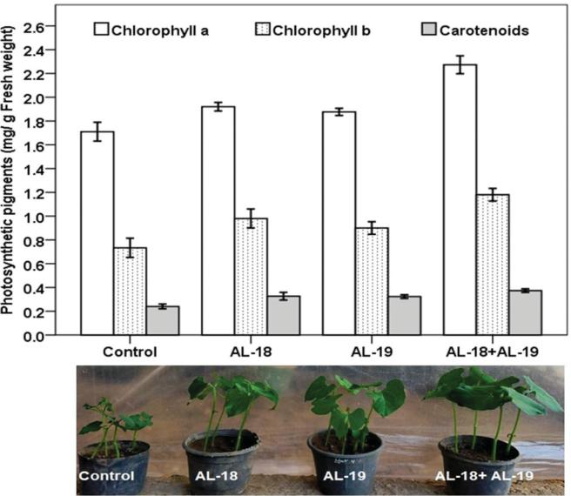

Figure 7. Effect of halotolerant phosphate solubilizing B. megaterium AL-18 and B. cereus AL-19 on photosynthetic pigments (Chlorophyll a, Chlorophyll b and Carotenoids) of common bean (Phaseolus vulgaris cv. Karnac) under salin-ity stress.

according to Mohan et al. (2017), halotolerant bacteria can be defined as microorganisms that can grow over a large variety of salt concentrations but thrive better in low salinities. This is possible by the presence of mechanisms that involve the osmo-adaptation as response to sodium stress and to over-come the toxicity of Na þ ion, such as accumulation of K against NaCl, and compatible solutes (low molar mass mole-cules) synthesis (Mohan et al. 2017; Srinivasan et al. 2012). In this sense, our results showed that Bacillus megaterium (strain AL-18) and Bacillus cereus (strain AL-19) can be considered as halotolerant microorganisms. This is in agreement with the reports of Ramadoss et al. (2013) who reported that halotoler-ant strains of Bacillus and Hallobacillus species isolated from saline soil were able to grow at higher concentrations of salt up to 20% NaCl due to formation of protective factors as well as adaptation with environmental conditions. In this way, Zhu et al. (2011) stated that a good example of halotolerant bac-teria is Kushneria sp. YCWA18 isolated from sediment of China coast that exhibited best growth at 6% NaCl and can be tolerate salinity up to 20% NaCl. On the other hand, the soil microorganisms can promote plant growth through sev-eral mechanisms; one of them is solubilization of insoluble phosphates. In this study, both B. megaterium AL-18, B. cereus AL-19 can solubilize insoluble phosphate under salt stress. Subsequently, the increase of phosphate content in inoculated common bean plants is due to microbial solubilization of phosphate and makes it available for plants. In this concern, phosphate content in Cicer arietinum, Vigna radiata and Oryza sativa plants was increased as a result of application of salt tolerant phosphate solubilizing B. cereus (Chakraborty et al. 2011). In this study, maximum growth parameters and P content were recorded with co-inoculation of two strains (AL-18 and AL-19) comparing to single inoculation and un-inoculated control. Similarly, Co-inoculation of both PSB strains Pantoea agglomerans (PSB-1) and Burkholderia anthina (PSB-2) showed maximum enhancement in length and dry

GEOMICROBIOLOGY JOURNAL  7

matter of shoot and root, and P uptake of mung bean plants (Walpola and Yoon 2013). Harmful effects of salinity which reflect on decrease of plant growth and nutrient uptake could be alleviating by several of salt tolerant microorganisms (Abdel et al. 2020; Chakraborty et al. 2011; Hahm et al. 2017). In our study, both phosphate solubilizing strains (AL-18 and AL-19) able to enhance phosphate nutrition, which may be partial responsible for the ability of inoculated plants to over-come salinity stress and alleviate the negative effects induced by salt stress (Hahm et al. 2017; Rady et al. 2018). The increase of growth parameters, phosphate contents and photo-synthetic pigments in inoculated plants could be attributed to the ability of both B. megaterium and B. cereus to solubilize phosphate and make it uptake by the plant easier as well as alleviation of harmful effects induced from salt-stress (Abdel et al. 2020; Chakraborty et al. 2011).

Conclusion

In conclusion, the present study suggests that B. megaterium AL-18, B. cereus AL-19 isolated from the rhizosphere of native plant (Tamarix ramosissima) growing in salt affected soil are salt-tolerant and phosphate solubilizers. Bacterial inoculations in Phaseolus vulgaris can alleviate the deleteri-ous effects of salinity and improve plant growth, phosphate uptake and photosynthetic pigments under salt stress condi-tions, which were demonstrated in vivo. However, field experiments under natural conditions are needed to study the mechanisms by which the identified strains induce salin-ity tolerance in plants.

Disclosure statement

No potential conflict of interest was reported by the author(s).

Funding

This study was supported by the Universidad Autonoma de Baja California and Menoufia University.

References

Abdel MNA, Abd EA, Ghoname AA. 2020. AMF and Bacillus megate-rium neutralize the harmful effects of salt stress on bean plants. Gesunde Pflanz 72(1):29–39.

Albdaiwi RN, Khaymi-Horani H, Ayad JY, Alananbeh KM, Kholoud M, Al-Sayaydeh R. 2019. isolation and characterization of halotoler-ant plant growth promoting rhizobacteria from durum wheat (Triticum turgidum subsp. durum) cultivated in saline areas of the dead sea region. Front Microbiol 10:1639.

ı ~

Ayra L, Ram rez M, Iniguez LP, Rodes R, Ortega E, Hernandez G. 2018. The common bean (Phaseolus vulgaris) basic leucine zipper (bZIP) transcription factor family: response to salinity stress in fer-tilized and symbiotic n2-fixing plants. Agriculture 8(10):160.

Batool S, Iqbal A. 2019. Phosphate solubilizing rhizobacteria as alterna-tive of chemical fertilizer for growth and yield of Triticum aestivum (Var. Galaxy 2013). Saudi J Biol Sci 26(7):1400–1410.

Chakraborty U, Roy S, Chakraborty AP, Dey P, Chakraborty B. 2011. Plant growth promotion and amelioration of salinity stress in crop plants by a salt-tolerant bacterium. Recent Res Sci 3(11):61–70.

8  A. ABDELMOTELEB AND D. G. MENDOZA

Hahm MS, Son JS, Hwang YJ, Kwon DK, Ghim SY. 2017. Alleviation of salt stress in pepper (Capsicum annum L.) plants by plant growth-promoting rhizobacteria. J Microbiol Biotechnol. 27(10): 1790–1797.

Hildebrand JL, Bains OS, Lee DSH, Kennedy CJ. 2009. Functional and energetic characterization of P-gp-mediated doxorubicin transport in rainbow trout (Oncorhynchus mykiss) hepatocytes. Comp Biochem Physiol C Toxicol Pharmacol. 149(1):65–72.

Khaitov B, Vollmann J, Yeong Pyon J, Park KW. 2020. Improvement of salt tolerance and growth in common bean (Phaseolus vulgaris L.) by co-inoculation with native rhizobial strains. J Agr Sci Tech-Iran 22(1):209–220.

Lobato AKS, Gonc¸alves-Vidigal MC, Vidigal Filho PS, Andrade CAB, Kvitschal MV, Bonato CM. 2010. Relationships between leaf pig-ments and photosynthesis in common bean plants infected by anthracnose. New Zeal J Crop Hort 38 (1):29–37.

Mendez-Trujillo V, Moreno-Ramırez L, Carrillo-Beltran D, Gonzalez-Mendoza D. 2013. Fast protocol for DNA isolation of DNA from bacterial isolated from a hyper-arid environment. J Pure Appl Microbiol 7:1–4.

Mohan V, Devi KS, Anushya A, Revathy G, Kuzhalvaimozhi GV, Vijayalakshmi KS. 2017. Screening of salt tolerant and growth pro-motion efficacy of phosphate solubilizing bacteria. J Sci Ind Res 5(12):168–172.

Morales-Santos ME, Pena~-Valdivia CB, Garcıa-Esteva A, Aguilar-Benıtez G, Kohashi-Shibata J. 2017. Seed and seedlings physical characteristics and seeds germination of wild and domesticated com-mon bean (Phaseolus vulgaris L.) and their progeny. Agrociencia 51(1):43–62.

Rady MM, El-Shewy AA, El-Yazal S, Abdelaal KE. 2018. Response of salt-stressed common bean plant performances to foliar application of phosphorus (MAP). ILNS 72:7–20.

Rahman CH, Miloud B, Rachid D, Ahcene B, Hakim H. 2017. Optimization of inorganic phosphate solubilization by Pseudomonas fluorescens and Bacillus sp. isolated from wheat rhizospheric soil. Int J Biosci 10 (4):142–150.

Ramadoss D, Lakkineni VK, Bose P, Ali S, Annapurna K. 2013. Mitigation of salt stress in wheat seedlings by halotolerant bacteria isolated from saline habitats. Springerplus. 2(1):6.

Saeid A, Prochownik E, Dobrowolska-Iwanek J. 2018. Phosphorus Solubilization by Bacillus Species. Molecules. 23(11):2897 doi:[10.](https://doi.org/10.3390/molecules23112897) [3390/molecules23112897](https://doi.org/10.3390/molecules23112897).

Srinivasan R, Yandigeri MS, Kashyap S, Alagawadi AR. 2012. Effect of salt on survival and P-solubilization potential of phosphate solubiliz-ing microorganisms from salt affected soils. Saudi J Biol Sci 19(4): 427–434.

Suleman D, Sani A, Ambardini S, Boer D, Yanti NA. 2019. Isolation and identification of phosphate solubilizing bacteria (PSB) from various plant rhizospheres and its ability to dissolve tricalcium phos-phate under in vitro condition. Biosci Res 16(3):2486–2495.

Sultanova N, Makhmoor T, Abilov ZA, Parween Z, Omurkamzinova VB, Ur-Rahman A, Choudhary MI. 2001. Antioxidant and anti-microbial activities of Tamarix ramosissima. J Ethnopharmacol 78(2–3):201–205.

Villar JL, Juan A, Alonso MA. 2014. Tamarix hohenackeri Bunge, un nuevo registro para la flora de Mexico. Acta Bot Mex 1(106): 117–128.

Walpola BC, Yoon MH. 2013. Phosphate solubilizing bacteria: Assessment of their effect on growth promotion and phosphorous uptake of mung bean (Vigna radiata [L.] R. Wilczek). Chilean J Agric Res 73(3):275–281.

Zhang A, Zhao G, Gao T, Wang W, Li J, Zhang S, Zhu B. 2013. Solubilization of insoluble potassium and phosphate by Paenibacillus kribensis CX-7: A soil microorganism with biological control poten-tial. Afr J Microbiol Res. 7:41–47.

Zhou N, Zhao S, Tian CY. 2017. Effect of halotolerant rhizobacteria isolated from halophytes on the growth of sugar beet (Beta vulgaris L.) under salt stress. FEMS Microbiol Lett. 364(11):fnx091.

Zhu F, Qu L, Hong X, Sun X. 2011. Isolation and characterization of a phosphate-solubilizing halophilic Bacterium kushneria sp. YCWA18 from Daqiao Saltern on the Coast of Yellow Sea of China. Evid Based Complement Alternat Med. 2011:615032.